History 101 - Western Civilization, Part I: Antiquity to the High Middle Ages
MWF 2:00 – 2:50 PM Pacific Hall Room 123
Instructor: Cary Barber
Office and Hours: McKenzie Hall 340W – Wednesday 12:00 – 1:00 PM and by Appointment
E-Mail: cbarber@uoregon.edu
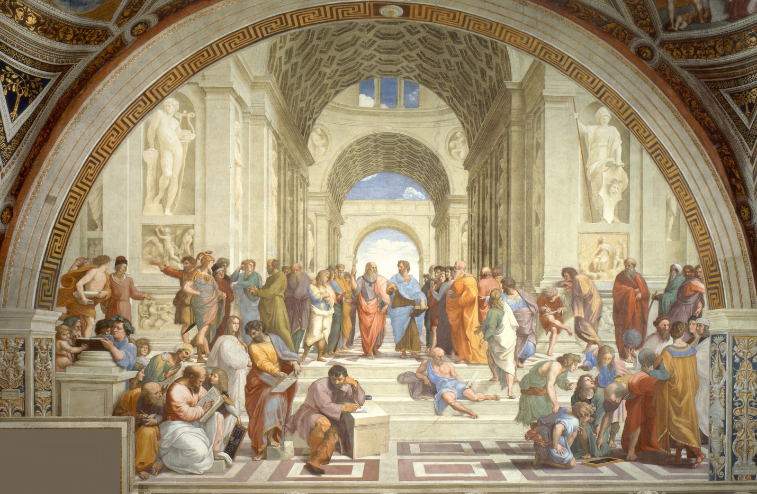
Raphael, “School of Athens”, 1510.
Class Goals and Objectives
Your primary goal in this class is to acquire both knowledge of and an appreciation for the early history of Western Civilization. As with all history courses, there will be some requirement that you learn basic facts, terms, locations, and dates. Though it may seem tedious to learn this information at first, you will come to realize that these are the foundations for any good understanding of history. Still, it is more important to me that you come away from this course with an extensive knowledge of the various political, social, economic, and religious trends and developments in European history up to about 1300 AD. And even more importantly, you will gain critical thinking about history and the world as a result of your newfound understanding of the trends and developments that make up history. You will be able to employ these new skills in historical analysis – both in future courses and in your daily lives – and you will improve your ability to discern bias and spin all around you in your daily lives.
Expectations
Students of this class are expected to attend regularly and complete all assignments and readings. All students must participate in class discussions and are expected to contribute regularly. WARNING: You must be engaged in this class if you wish to receive a high mark.

University Policies

Required Texts
Cole, Joshua and Symes, Carol. Western Civilizations. W.W. Norton & Company – 19th edition!! (WC in syllabus)
I will provide online links and scans of primary sources – make sure you check online for them each week!

Grading Scale
A: 92.6 and above; B: 82.6-87.5; C: 72.6-77.5; D: 62-67.5;
A-: 89.6-92.5; B-: 79.6-82.5; C-: 69.6-72.5; E: below 62
B+: 87.6-89.5; C+: 77.6-79.5; D+: 67.6-69.5;
Course Requirements and Due Dates
Grade Calculation
Recitation Quizzes 10%
Recitation Attendance + Discussion 10%
Recitation Assignments 10%
Mid-Term #1 10%
Mid-Term #2 10%
Paper Prospectus 5%
Paper 25%
Final Exam 20%

Total Grade 100%
Attendance/Discussion/Participation
You must participate actively in order succeed in this class. For those of you who are reluctant to speak up during class and recitation or are concerned that your participation is not being recognized, please free to speak either with your or recitation section leader or with me outside of class or during office hours to ensure that you receive due credit. In general, however, as long as you make an active effort to engage with the course materials and prove this effort in some way, you will gain participation credit. I am very flexible as to how you achieve this requirement. If you participate frequently, you may receive extra credit at my discretion!
We will move at a relatively brisk pace this quarter because we’re moving through some 4,000 years in only 10 weeks. As a result, I expect you to attend class every day in order to keep up with discussion and with lecture. I do, however, understand that emergencies occasionally arise and that you may not be able to attend class. You may have up to two unexcused absences in recitation for the entire quarter, after which each absence will lower your overall grade by a half of a letter grade! Attendance will be taken each recitation at the beginning of class, so if you happen to arrive a few minutes late, please make sure you come up and sign the attendance sheet afterwards.
Quizzes
There will be several quizzes in recitation throughout the fall based on material from lecture and readings. These will often be unannounced, and they will count for 10% of your grade. Some of them will be dropped. If you are unexcused-absent for a quiz beyond the two absences that you are given, you will receive a 0 for that quiz grade. These quizzes are important for me in that they gauge how well you are absorbing what you hear and read. They are not just to make you sweat and grumble! As long as you receive a passing grade on the quiz, you will get full credit.
Recitation Assignments and Projects
You will often be asked to complete a project or an assignment for your recitation section. These will be announced either in class or online. Some of these will be assigned to you as individuals and some will require you to work in your recitation groups. You will have ample time to prepare for these, but make sure you work together with your group-mates to set up a schedule to meet outside of class.
Exams
There will be two exams worth 10%; and the final exam worth 20%. These will have several sections, including identification, multiple choice, and short answer. These must be taken in class during the time allotted to you, and make-ups will be available only for excused absences. If you do not think you can attend for any reason, please e-mail me or your recitation section leader beforehand and we will work out a solution.
Papers and Paper Prospectus
There will be one final paper assigned in this course, and it will be worth 25% of your grade. As a part of this assignment, you will also turn in a prospectus to your recitation TA, who will sign off on your topic and the sources you’ve found for it. This prospectus will be worth 5%, and it will be due several weeks before your paper is due (at the end of the course).
Essentially, I would like you to find a topic within the class that you found particularly interesting, and I would like you to write a small research paper on it. You will receive more information about this online and from a typed-up assignment sheet that I will distribute in your recitation sections later in the quarter. I expect each paper to be approximately 1250 words, double spaced, regular margins, 12 pt. font. These papers will engage with the primary sources assigned to you along with lecture, reading from the textbook, and your own research. They will be graded (1) based on your ability to think critically about a problem using all of the materials available to you and (2) quality and accuracy of prose, grammar, and style. Late papers will be penalized by five points per day, including weekends. You may use whatever citation type you like, but make sure you are consistent.

Course Schedule and Assignments
(Read and take notes on each assigned reading before the date listed – Schedule subject to change!)
Week One (Sept. 25 – 29)
Monday – September 25 – Introduction
- Introduction and Organization
Wednesday – September 27 – The Rise of Civilization: Mesopotamia and the Near East
- WC: Chapter 1 pg. 3 – 37
Friday – September 29 – The Mediterranean and Near Eastern Milieu (2000 – 500 BC)
- WC: Chapter 2 pg. 39 – 73

Week Two (Oct. 2 – 6)
Monday – October 2 – Minoans, Mycenaeans, and the Greek Dark Age
- WC: Chapter 2 pg. 48 – 54 and Chapter 3 pg. 76 – 87
- Selections from various philosophers and poets
- Start reading Homer Iliad selections
Wednesday – October 4 – Rise of the Polis
- WC: pg. 88 – 96
- Finish reading Homer Iliad selections
Friday – October 6 – Persian Wars + Classical Athens and Sparta
- WC: pg. 96 – 101
- Selections from Herodotus and Thucydides

Week Three (Oct. 9 – 13)
Monday – Classical Greece: Peloponnesian War + Fourth Century Revolution
- WC: pg. 101 – 122
- Selections from Thucydides: Pericles’ Funeral Oration; the Plague of Athens; the Mytilenian Debate; and the Melian Dialogue!
Wednesday – October 11 – Alexander and the New Hellenistic World
- WC: pg. 122 – 145
- Study for Midterm
Friday – October 13 – MIDTERM #1!

Week Four (Oct. 16 – 20)
Monday – October 16 – The Early Roman Republic: Mythical Beginnings
- WC: pg. 146 – 156
- Selections from Livy, etc.
Wednesday – October 18 – The Middle Roman Republic: The Rise of an Empire
- WC: pg. 156 – 162
- Selections from Polybius, etc.
Friday – October 20 – The Late Roman Republic: The Collapse of the Republic
- WC: pg. 162 – 165
- Selections from Cicero, etc.
- Begin reading Augustus’ Res Gestae, Tacitus, and others in module

Week Five (Oct. 23 – 27)
Monday – October 23 – Augustus and the Rise of the Principate
- WC: pg. 165 – 168
- Augustus’ Res Gestae, Tacitus, and others in module
Wednesday – October 25 – The Pax Romana and the Expansion of the Roman Empire
- WC: pg. 168 – 179
- Selections from Seneca, etc.
Friday – October 27 – New Challenges and the Third Century Crisis
- WC: pg. 189 – 193
- Selections from the Theodosian Code, etc.

Week Six (Oct. 30 – Nov. 3)
Monday – October 30 – Christianity, Late Antiquity and the Transformation of the Roman Empire
- WC: pg. 179 – 189, 191 – 198
- Selections from Eusebius, etc.
Wednesday – November 1 – Late Antiquity and the Transformation of the Roman Empire
- WC: pg. 194 – 211
- Selections from Ammianus Marcellinus, etc.
- Study for Mid-Term!
Friday – November 3 – MIDTERM #2

Week Seven (Nov. 6 – 10)
Monday – November 6 – Heirs to the Roman Empire: Byzantium
- WC: pg. 212 – 223
- Selections from Procopius, etc.
Wednesday – November 8 - Heirs to the Roman Empire: Islam
- WC: 223 – 230
- Selections from the Qur’an, etc.
Friday – November 10 – Heirs to the Roman Empire: Early Medieval World in the West
- WC: 230 – 247
- Selections on Charlemagne, etc.
- Begin Song of Roland

Week Eight (Nov. 13 – 17)
Monday – November 13 – Europe in 1000 BC and New Changes
- WC: 247 – 255
- Song of Roland
Wednesday – November 15 – Expansion of Europe
- WC: 255 – 266
- Selections on Early Medieval Ages (Charters, etc.)
Friday – November 17 – Beginnings of Crusader Era
- WC: 266 – 283
- Selections on Early Crusades (Papal Edicts, etc.)

Week Nine (Nov. 20 – 24)
Monday – November 20 – Consolidation of Europe: Narratives and Timelines
- WC: 283 – 294
- Selections on the Rise of France, etc.
Wednesday – November 22 – Unity and Dissent in the Western Church
- WC: 294 – 323
- Selections on the Church, etc.
Friday – November 24 – NO CLASS! Happy Thanksgiving!

Week Ten (Nov. 27 – Dec. 1)
Monday – November 27 – Reorientation of the Medieval World
- WC: 324 – 342
- Selections from Marco Polo, etc.
Wednesday – November 29 – The High Middle Ages
- WC: 342 – 350
- Selections from Dante, etc.
Friday – December 1 – The Impact of the Black Death
- WC: 350 – 357
- Selections on the Black Plague

FINAL EXAM IS THURSDAY, DECEMBER 7TH AT 2:45 PM

